**INT 6000 CEM (Group 13) - Event Management System - User Manual**

GitHub source code link: [**https://github.com/wewmkwm/EventManage/tree/main**](https://github.com/wewmkwm/EventManage/tree/main)

Contents

Step 1: GitHub link source code download 3

Step 2: Move to Xampp 4

Step 3: Extract and rename folder 5

Step 4: Xampp control panel 6

Step 5: Import database 7

Step 6: Start up and login 8

Step 7.1: User 9

Step 7.2: Company 10

Step 7.3: Admin 11

# Step 1: GitHub link source code download

* Download the source code from the GitHub repository link: <https://github.com/wewmkwm/EventManage/tree/main>
* Download in ZIP file format.

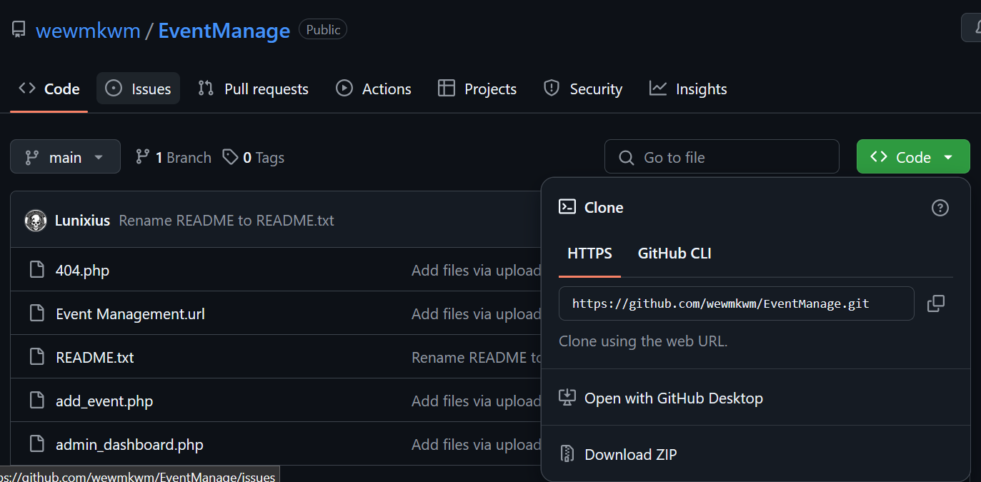

# Step 2: Move to Xampp

* Once downloaded the file, move the file to the following directory:  
  (Specified disk)\Xampp\htdocs



* If you do not have Xampp downloaded, you may use the link to download and move to your specified disk from below:

<https://www.apachefriends.org/download.html>

# Step 3: Extract and rename folder

* Once moved the file into htdocs, extract the folder into the directory.
* Rename the folder from EventManage-main to EventManage.



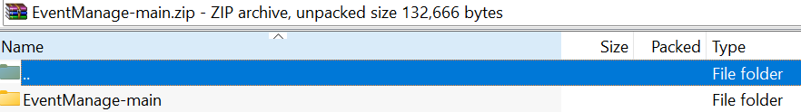



# Step 4: Xampp control panel

* Open XAMPP control panel, and start up Apache and MySQL.
* Click on MySQL – Admin to <http://localhost/phpmyadmin/>.

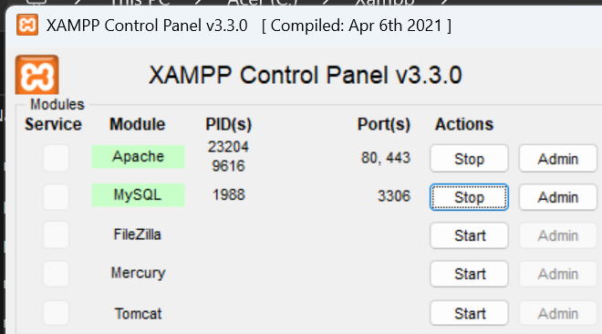

# Step 5: Import database

* Create a new database called “event”
* Go to “Import” and import the “event” SQL file from the “EventManage folder” into the “event” database.

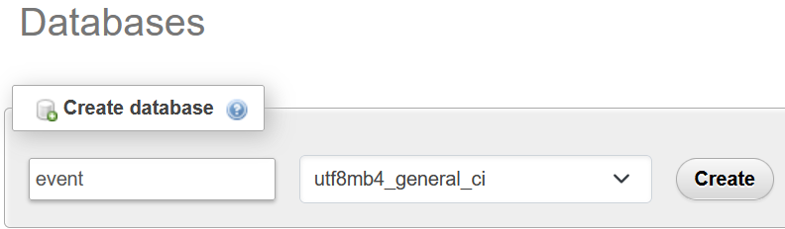



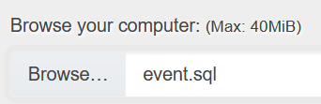

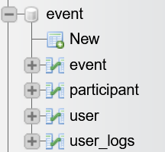

# Step 6: Start up and login

* From an online browser (Firefox, Chrome etc.), type in the following url: <https://localhost/EventManage/login.php> .
* For the starting login data for user, company and admin, open the “user account” plain text from the “EventManage” folder for the login credentials, use sign up function to register a new account or head to the ‘user’ data model for user details: <http://localhost/phpmyadmin/index.php?route=/sql&pos=0&db=event&table=user>

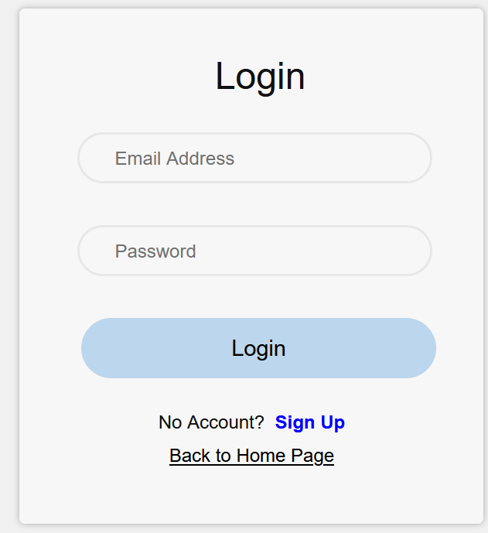



# Step 7.1: User

* Once logged in as a user, you may select any available posted events to join.
* You can use search bar for name filter search, then click on “Join” of an event to join the selected available event.

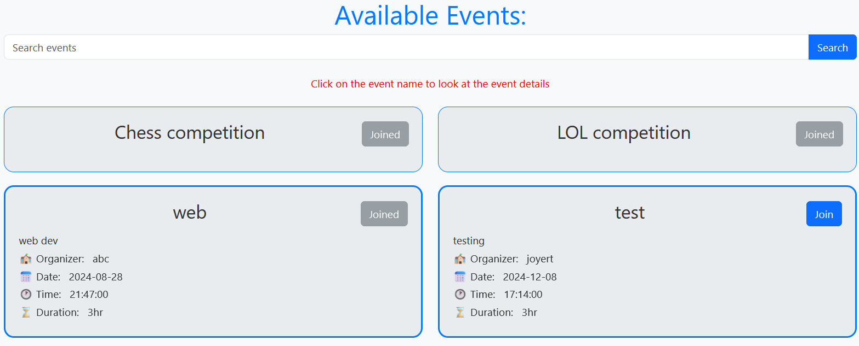

# Step 7.2: Company

* Once logged in as a company, you may browse any available events and participant list.
* You can add a new event by “Add event” on the top right of the “My Events” tab, and fill in the new event info.

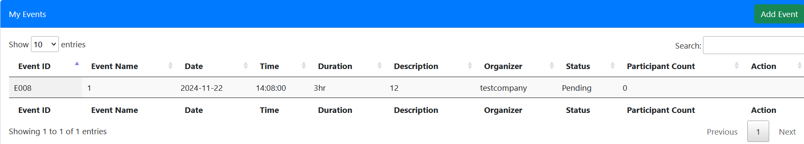

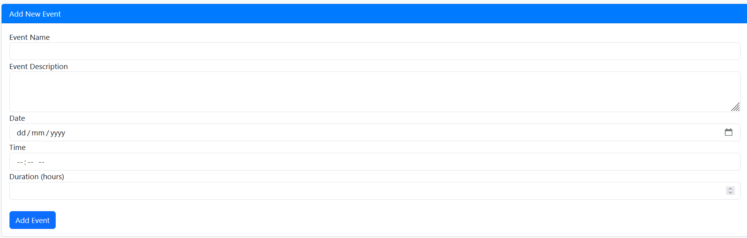

# Step 7.3: Admin

* Once logged in as an admin, you may browse through the list of data pages for management:

1. Dashboard
2. Pending Events
3. Approved Events
4. Ended Events
5. View Users

* Dashboard presents the data of Recent User Activity, Users Who Joined Events and Companies and Their Created Events.

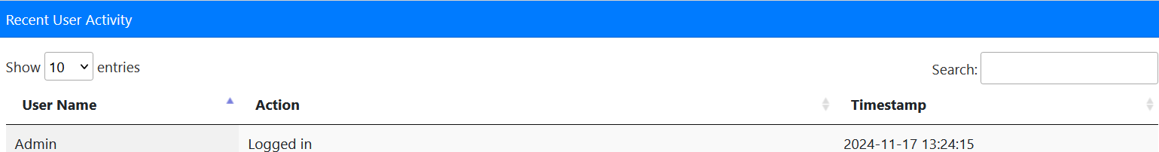

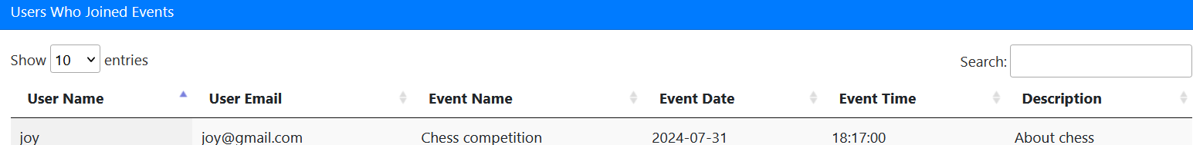

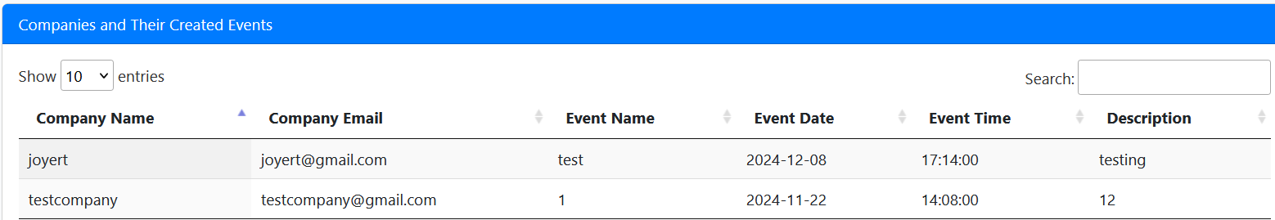

* Pending events shows newly created events by the company, as the admin may chose to approve or reject an event.

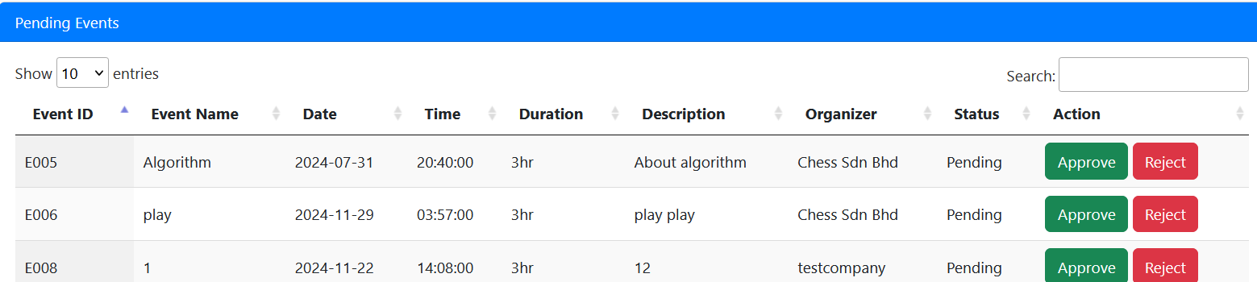

* Approved events will be displayed in Approved Events about any approved events by the admin.

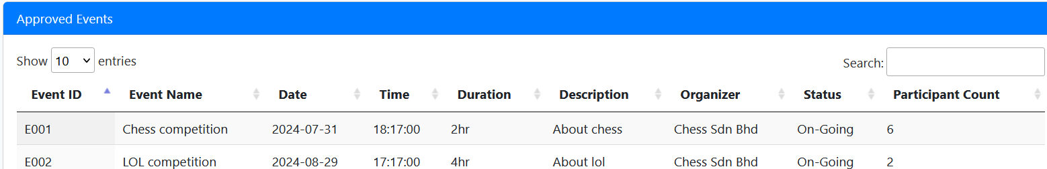

* Ended events displays any events past their hosting time, or events that aware rejected by the admin.

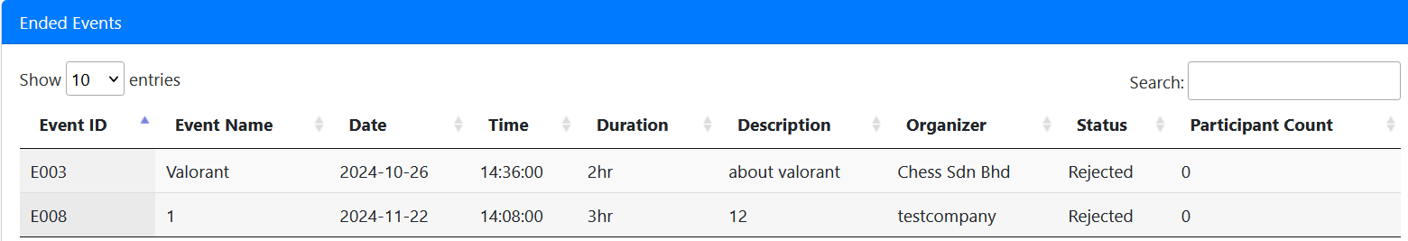

* View users displays the data of any registered users; the admin choose whichever user or company account to delete.

